Stress v Performance Curve Explanation in the Report
The stress/performance curve illustrates the relationship between performance (vertical scale) and stress (horizontal scale).

A certain level of pressure is needed to reach the ‘sweet spot’ of optimal
performance, but prolonged pressure and stress may lead to exhaustion.

Remaining in the exhaustion phase over a long period of time causes performance to decline, and without the chance to reset, this can lead to illness or even burnout.

Burnout, as defined by the World Health Organisation as chronic workplace stress that hasn’t been managed effectively. Illness is characterised by short periods of absence from work, whilst burnout is usually associated with extended periods of absence.

On the left side of the curve, you may feel ‘bored’ if the role doesn’t test your capabilities. The ‘challenged’ phase can apply to those struggling to reach optimal performance, perhaps due to being new, unclear roles or priorities, or team conflict.

The following pages show the 6 stages of the Stress Performance Curve that may appear in an individual’ report.

Note that this is a self-assessment at a moment in time. The report shows where the individual assesses themselves ‘now’ on the stress v performance curve.

Insights from the Stress v Performance Curve Data

When working with groups or teams, the distribution of the group across the stress v performance curve can provide us clear insights into the ‘health’ and well-being of the group.

Our analytics show that typically 30% of people are in Optimal Performance, 29% challenged, 6% bored, 31% exhaustion, 3% illness, 1% burnout. ( Based on data from 1,750 Assessments). For smaller samples, data distribution may vary significantly from this distribution.

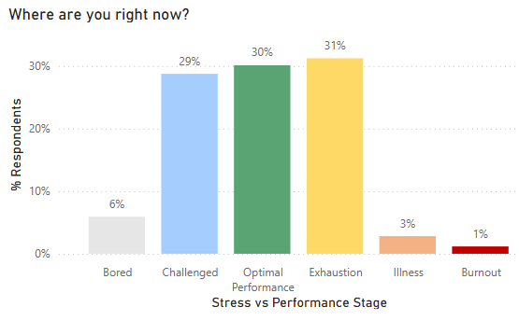

Harmful stress is defined as people in the Exhaustion, Illness, Burnout categories which from the analytics below amount to 35% of the people.
Report Wording for Each Stage of the Stress v Performance Curve

- Bored

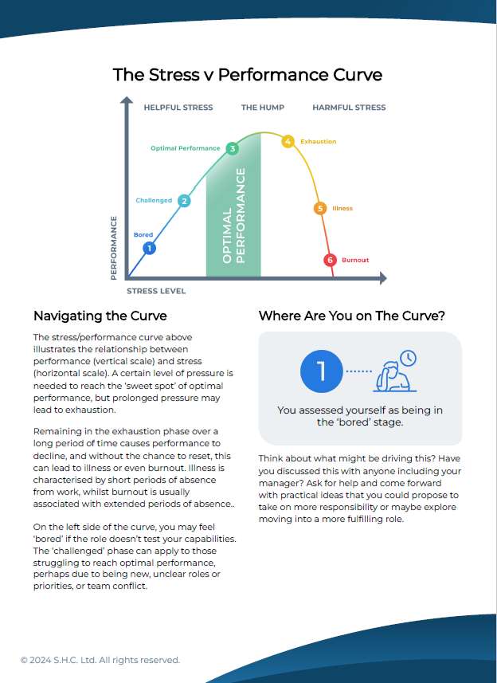

- Challenged
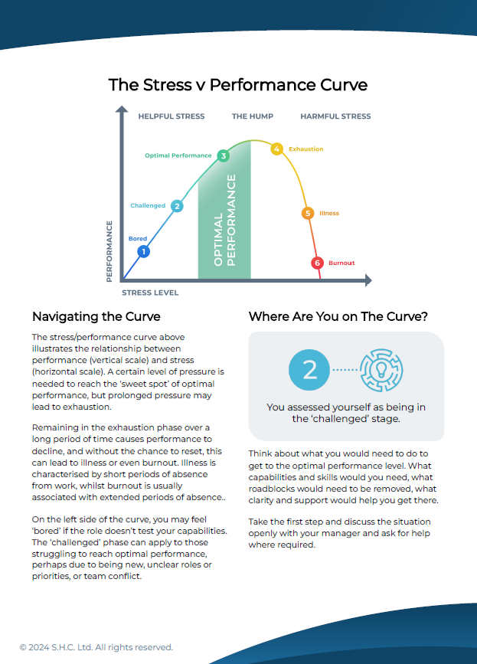
- Optimal Performance
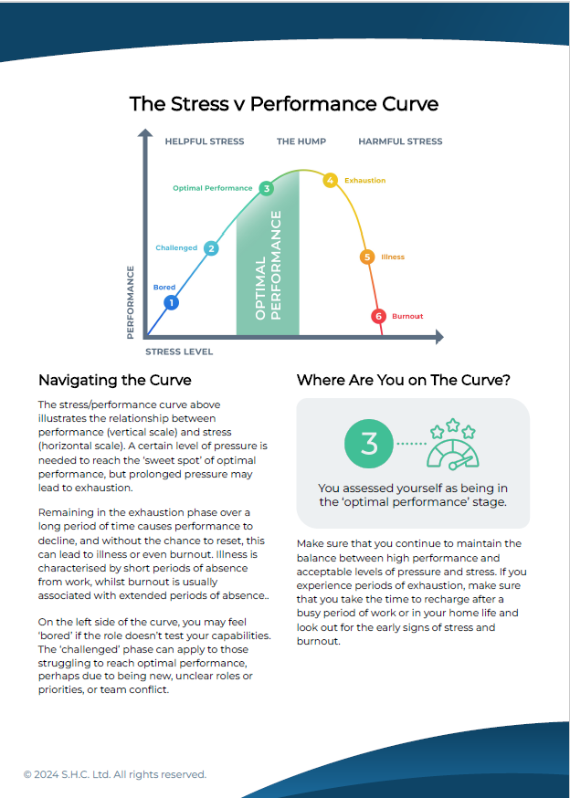

- Exhaustion
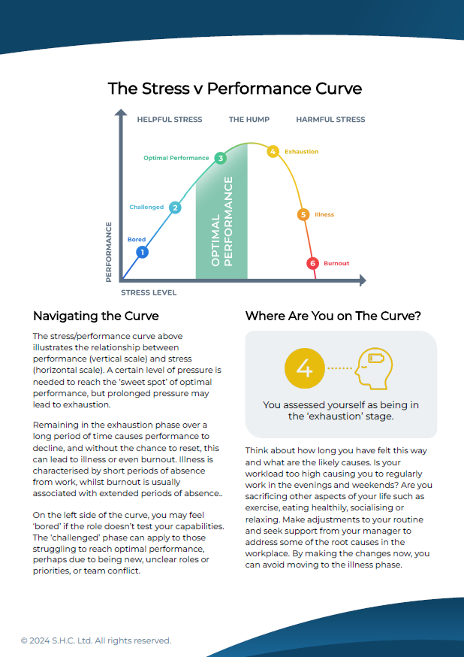

- Illness
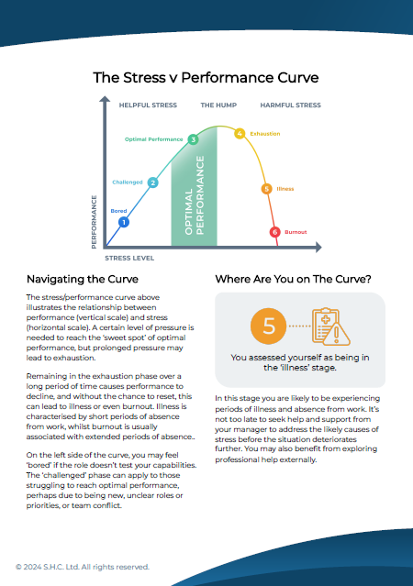
- Burnout
